**LISTING**

**ALGORITMA DAN PEMROGRAMAN**

**PERTEMUAN KE-6**

**PRAKTIK 1**

1. Scenario

import java.util.Scanner;

public class Scholarship{

public static void main(String[]args){

Scanner sc= new Scanner(System.in);

System.out.println("Enter Your Grade?");

int nGrade= sc.nextInt();

System.out.println("Enter Your Absent?");

int nDaysAbsent= sc.nextInt();

if(nGrade>=88){

if(nDaysAbsent==0){

System.out.println("You quality for scholarship");

}

}

}

}

Output :

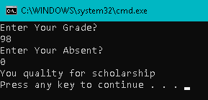

**PRAKTIK 2**

1. Using logical &&

import java.util.Scanner;

public class Scholarship1{

public static void main(String[]args){

Scanner sc= new Scanner(System.in);

System.out.println("Enter Your Grade?");

int nGrade= sc.nextInt();

System.out.println("Enter Your Absent?");

int nDaysAbsent= sc.nextInt();

if(nGrade>=88 && nDaysAbsent==0){

System.out.println("You quality for scholarship");

}

else{

System.out.println("You do not qualify for scholarship");

}

}

}

Output :

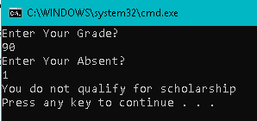

1. Logical operator “Or”

import java.util.Scanner;

public class Scholarship2{

public static void main(String[]args){

Scanner sc= new Scanner(System.in);

System.out.println("Enter Your Grade?");

int nGrade= sc.nextInt();

System.out.println("Enter Your Absent?");

int nDaysAbsent= sc.nextInt();

if(nGrade>=88 || nDaysAbsent==0){

System.out.println("You quality for scholarship");

}

else{

System.out.println("You do not qualify for scholarship");

}

}

}

Output :

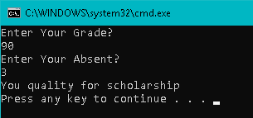

1. Logical operator “Not”

public class NotOperator{

public static void main(String[]args){

int numberDaysAbsent= 2;

int grade= 65;

boolean madeFreeTutor= grade >=88;

if(!madeFreeTutor && numberDaysAbsent<3){

System.out.println("You qualify for free tutoring help");

}

}

}

Output :

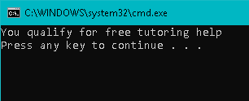

**PRAKTIK 3**

1. Skipping the second AND test

public class ShortCircuitAnd{

public static void main(String[]args){

int x= 0;

int y= 2;

boolean b;

b= (x!=0) && ((y/x)>2); // mengapa tidak terjadi error di baris ini

System.out.println(b);

}

}

Output :

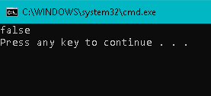

1. Short circuit Or

public class ShortCircuitOr{

public static void main(String[]args){

int x= 25;

boolean b= (x>=10) || (x<20);

System.out.println(b);

}

}

Output :

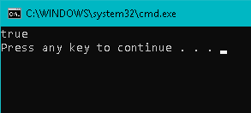

**PRAKTIK 4**

1. Ternary scenario

public class TrackingGoal{

public static void main(String[]args){

int numberOfGoals= 5;

String s;

if(numberOfGoals == 1){

s= "goal";

}

else{

s= "goals";

}

System.out.println("I scored " + numberOfGoals + " "+s);

}

}

Output :

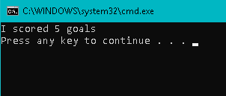

1. Ternary operator

public class TernaryOperator{

public static void main(String[]args){

int numberOfGoals= 1;

System.out.println("I score " +numberOfGoals+ " " +(numberOfGoals==1 ? "goal" : "goals"));

}

}

Output :

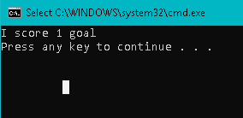

**PRAKTIK 5**

1. If construction

public class ChainingIf1{

public static void main(String[]args){

double income= 30000, tax;

if(income<=15000){

tax= 0;

}

else if(income<=25000){

tax= 0.05* income- 15000;

}

else{

tax= 0.05*(income-(25000-15000));

tax += 0.10*(income-25000);

}

System.out.println("Tax= "+tax);

}

}

Output :

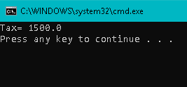

1. Nested if construction

public class NestedIf{

public static void main(String[]args){

String tvType= "color";

int size= 16;

int discPercent= 0;

if(tvType.equals("color")){

if(size==14){

discPercent= 8;

}

else{

discPercent= 10;

}

}

System.out.println("discPercent= " +discPercent);

}

}

Output :

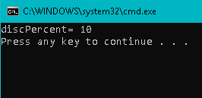

**LATIHAN**

1. Watch movie

import java.util.Scanner;

public class Latihan1{

public static void main(String[]args){

int harga, rating;

Scanner sc= new Scanner(System.in);

System.out.print("Masukkan harga tiket: $");

harga= sc.nextInt();

System.out.print("Masukkan rating film: ");

rating= sc.nextInt();

if(harga>=12){

if(rating==5){

System.out.println("I'm interested in watching the movie");

}

}

else{

System.out.println("I am not interested in watching the movie");

}

}

}

Output :

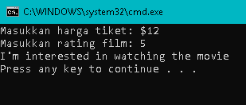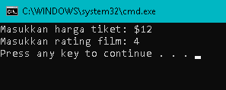

1. Odd and even

import java.util.Scanner;

public class Latihan2{

public static void main(String[]args){

int number;

Scanner sc= new Scanner(System.in);

System.out.print("Enter a number :");

number= sc.nextInt();

System.out.println((number%2==0 && number<=10)?"number is even":((number%2!=0 && number<=10)?"number is odd":"error index"));

}

}

Output :

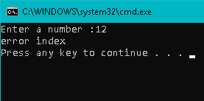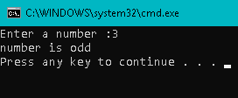

1. Age and fare

import java.util.Scanner;

public class Latihan3{

public static void main(String[]args){

int age;

Scanner sc= new Scanner(System.in);

System.out.print("Enter Your Age: ");

age= sc.nextInt();

if(age<11){

System.out.println("your fare is $3");

}

else if((age>11) && (age<65)){

System.out.println("Your fare is $5");

}

else{

System.out.println("your fare is $8");

}

}

}

Output :

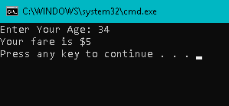

**TUGAS**

1. Spp variable

import java.util.Scanner;

public class Tugas {

public static void main(String[]args){

double IPK;

int teori,praktik,praktikum,sppVar,tAkhir, tDiskon;

teori = 80000;

praktik = 120000;

praktikum = 150000;

System.out.println("Teori : Rp."+teori+"/sks | Praktik : Rp."+praktik+"/sks | Praktikum : Rp"+praktikum+"/sks");

Scanner input = new Scanner(System.in);

System.out.print("Masukkan jumlah sks Teori : ");

int sksTeori = input.nextInt();

System.out.print("Masukkan jumlah sks Praktik : ");

int sksPraktik = input.nextInt();

System.out.print("Masukkan jumlah sks praktikum : ");

int sksPraktikum = input.nextInt();

System.out.println("Jumlah sks teori anda :"+sksTeori+" *"+teori);

System.out.println("jumlah sks praktik anda : "+sksPraktik+" *"+praktik);

System.out.println("jumlah sks praktikum anda :"+sksPraktikum+" *"+praktikum);

sksTeori = sksTeori*teori;

sksPraktik = sksPraktik*praktik;

sksPraktikum = sksPraktikum*praktikum;

sppVar = sksTeori+sksPraktik+sksPraktikum;

System.out.println("Total Spp Variable :"+sppVar);

System.out.print("Masukkan IPK : ");

IPK = input.nextDouble();

if(IPK>=3.0){

System.out.print("Anda mendapat diskon 25% dari total spp Vairable");

System.out.println(" = (25*sppVariable)/100");

tDiskon = (sppVar*25)/100;

System.out.println("Total Diskon :"+tDiskon);

tAkhir= sppVar-tDiskon;

System.out.println("Total bayar :" +tAkhir);

}

else{

System.out.println("Anda tidak mendapatkan diskon");

System.out.println("Total Bayar :"+sppVar);

}

}

}

Output :

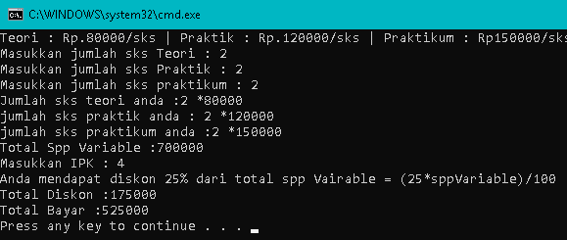

1. IPK value

import java.util.Scanner;

public class TugasNilai{

public static void main(String[]args){

int nNIM, tugas, UTS, UAS, nakhir;

Scanner sc= new Scanner(System.in);

System.out.print("Masukkan NIM: ");

nNIM= sc.nextInt();

System.out.print("Masukkan Nilai tugas: ");

tugas= sc.nextInt();

System.out.print("Masukkan Nilai UTS: ");

UTS= sc.nextInt();

System.out.print("Masukkan Nilai UAS: ");

UAS= sc.nextInt();

nakhir= ((tugas*30/100)+(UTS*30/100)+(UAS*40/100));

System.out.println("Nilai akhir: "+nakhir);

if(nakhir>=80){

System.out.println("Nilai A");

}

else if(nakhir>=70 && nakhir<=79){

System.out.println("Nilai B");

}

else if(nakhir>=60 && nakhir<=69){

System.out.println("Nilai C");

}

else if(nakhir>=50 && nakhir<=59){

System.out.println("Nilai D");

}

else{

System.out.println("Nilai E");

}

}

}

Output :

